**Lab 06 Submission Template**

**Name:** Multani Aman Altaf

**Student Number:** 040877727

# Task 0: (no marks but zero for the submission it’s missing)

Insert task0_ip.jpg

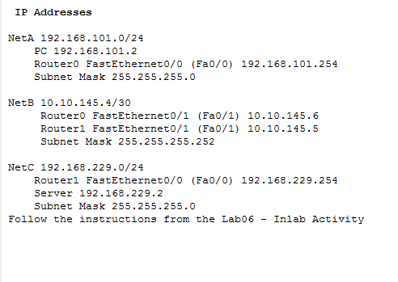

# Task 3: Questions (1 Mark each)

1. .Open the Desktop command prompt on the PC and ping the server again. Use the capture forward button to move the packet to Router0. Click on the PDU and then the inbound PDU details tab.
   1. What is the value of the TTL field in the IP Header? 128
   2. What are the values of the Type and Code fields in the ICMP header? Type:0x8 Code:0x0
2. Look at the Outbound PDU details tab and see if any of the values recorded in the above step have changed? What field and value (if any) changed? Inbound DEST MAC: 00D0.978A.D501 SRC MAC: 000A.F3D4.1C7B TTL:128 Outbound DEST MAC: 0001.4344.4102 SRC MAC: 00D0.978A.D502-TTL:127
3. Close the PDU information window. Use the capture forward button to move the PDU to the Server and back to Router0. . Click on the PDU and then the inbound PDU details tab.
   1. What is the value of the TTL field in the IP Header? 127
   2. What are the values of the Type and Code fields in the ICMP header? type:0x0 code:0x0
4. What’s different between the Inbound and outbound PDUs? Inbound DEST MAC: 00D0.978A.D502 SRC MAC: 0001.4344.4102 TTL:127 Outbound DEST MAC: 000A.F3D4.1C7B SRC MAC: 00D0.978A.D501 TTL:126
5. What’s different in the ICMP header between this PDU and the one you observed in Step 4 The Type has changed from 0x8 to 0x0

# Task 4: Questions (1 mark each)

5. Examine this PDU (outbound PDU details) and record the following:

* 1. Source IP: 192.168.101.254
  2. Destination IP 192.168.101.2
  3. ICMP Type: and Code: Type: 0xb Code: 0x0
  4. What comes after (below) the ICMP header? Describe what it is. Hint: examine the inbound PDU at Router0 . Inbound PDU of rounter 0
  5. What was the final device for the PDU? (a new PDU will be created at the final device) Router 1
  6. In the PDU that was generated, what are the source and destination IPs? Source: 192.168.101.2 Destination: 192.168.229.2

1. How far does the PDU travel? Router 0
2. What are the ICMP type and code values of the returned PDU? Type: 0x3 Code:0x1
3. What meaning does the ICMP packet have? Type : destination unreachable Code: Tells host unreachable
4. Use the Capture/Forward button to move the PDU to the server
   1. What type of PDU is moving towards the server (look in the Event List)? UDP
5. At the Server a new PDU will be created.
   1. What type is it? ICMP
   2. What are the ICMP type and code values of the returned PDU? Type: 0x3 Code: 0x3
   3. What meaning does the ICMP packet have? Type : Unreachable Code : Tells Port Unreachable

**Don’t forget to upload your completed Packet Tracer activity file. This need to be done as a separate file**